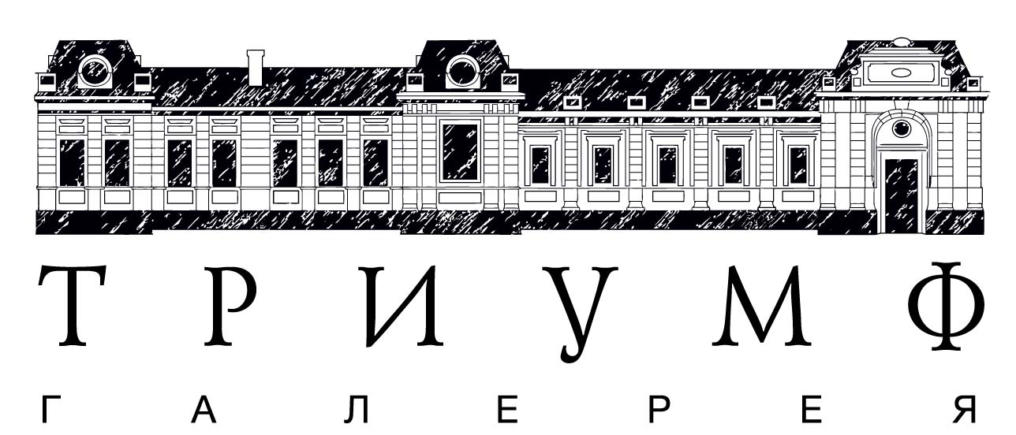
Department of Culture of Moscow
Museum Exhibition Association Manege
Manege / MediaArtLab Centre for Art and Culture
Triumph Gallery

EXHIBITION
“THE FOG. A STOP” BY NIKOLAY ONISHCHENKO
Within the Great Expectations series

Exhibition Opening: 23 of June 2014, 19:00
Exhibition is held: 24 of June 2014 – 13 of July 2014
Venue: central Exhibition Hall Manege,
Manege Square, building 1, second floor, Media library
Curator: Elena Rumyantseva

Nikolay Onishchenko (born 1979 in Voronezh) graduated from the Department of Graphic Art of Voronezh State Pedagogy University and the Institute of Contemporary Art (Moscow). In his new project called The Fog. The Stop the artist addresses a topic of illusory nature of reality. In his video works Onishchenko suggests a way to overcome “bias” of the first glance and a possibility to experience an ability of “pure” perception of space and time by taking a meditative step back.

Viewer’s look is fixed on empty playgrounds and underground parking lots being transformed into transit zones of urban environment. They represent a metaphor of a stop, of a temporary interruption of the usual course of events. Fog beclouding the image and meditative electronic buzz replacing usual background sound gradually transform the image into the “white noise”. A slow rhythm transforms the narrative into dynamic, almost monochrome graphics. In this regard, Nikolay Onishchenko’s videos remind of Michael Haneke’s movies: static scenes and detached view of the artist lend almost cinematographic aura to his works.

The exhibition project The Fog. A Stop continues the artist’s series, in which time and space intertwine and stratify, giving an extra dimension to the viewer’s perception. Minimalism of means of expression and almost complete absence of narrative in Nikolay Onishchenko’s works create a possibility of exit into a state of pure contemplation.

ACCREDITATION:
+7 (495) 645 92 76, pr.manege@gmail.com
Anastasia Chuguevskaya a.chuguevskaya@moscowmanege.ru
Vladislav Chubar v.chubar@moscowmanege.ru
Iva Ostistaya i.ostistaya@moscowmanege.ru
Marina Bobyleva, Triumph Gallery marina@triumph-gallery.ru

Nikolay Onishchenko works with video, photo, installation, performance, graphics and painting. Lives and works in Moscow.
Solo shows: «Garbage and Senses» (BOREY ART CENTER, St.Petersburg, 2014), Metaobjects («Perimeter» art platform, Moscow, 2014), «Industrial romance» (Moscow, CCA WINZAVOD, 2011).
Group shows: «Urbanism, Pro&Contra», (Cult-project Gallery, Moscow, 2014), Uchronia, V Moscow Biennale of Contemporary Art (Museum of Architecture, Moscow, 2014), «Expanded Cinema – 3. Mocumentary: Reality is not enough» (MMoMA, Moscow, 2014), «Outdoors! » (ArtPlay Design Center, Moscow, 2012), «Sorry, can I try next time?» (Art.Ru Agency, Moscow, 2012), Reflexion Total (Viseum Wetzlar, Germany, 2012), «Impossible Community» (MMoMA, Moscow, 2011), FRAGILE – VII International biennale of contemporary art (Shiryaevo, Samara, 2011), «Inner Emigration» (CCA WINZAVOD, Moscow, 2011), ArtHouse Genzel (Germany, 2011), «Transformations» (KhLAM Gallery, Voronezh, 2010), «On the Contrary» (CCA WINZAVOD, Moscow, 2011), «Relative freedom» VIII International Festival of Experimental Art (St.Petersburg, 2010), «Infrastructure» (Moscow, 2010), I Photobiennale of the Russian Museum (St.Petersburg, 2009), «Signs of absurd» (performance, St.Petersburg, 2009).
Curatorial projects: «ВездеVezde» (Spider&Mouse Gallery, Moscow, 2010).

Museum Exhibition Association Manege includes six exhibition spaces within Moscow city: Central Exhibition Hall Manege, Moscow State Exhibition Hall New Manege, Museum Exhibition Centre “Worker and Kolkhoz Woman”, Museum-Studio of People’s Artist of the USSR D.A.Nalbandyan, Exhibition Hall «Chekhov’s House», Moscow Museum of Sidur. In September 2012 Government of Moscow and Department of Culture of Moscow designed a new concept of development of the MEA Manege, according to which the work of exhibition spaces is aimed on holding large scale exhibitions and realization of image-forming projects in various areas of art.
.

Triumph Gallery was founded by Emelyan Zakharov and Dmitry Khankin in 2006. The gallery works with contemporary art and collaborates with major Russian and international artists. The most famous Russian artists of the gallery are AES+F, Alexander Vinogradov and Vladimir Dubosarsky, Alexey Belyaev-Gintovt, Recycle. Besides projects in its own space, the Triumph curates large scale exhibition projects in Russia and internationally, and supports young art within the Launchpad project. Since 2013 together with the Manege / MediaartLab the gallery organized exhibitions of young artists within the Great Expectations project.
MediaArtLab Centre for Culture and Art is run for more than 14 years and is the first Russian institution to engage in work with media art in Russia. It is an independent non-profit organization, which operates within the spheres of culture and informational communicational media technologies. MediaArtLab works on building practical and theoretical basis for development of innovation projects in the sphere of media culture in Russia by organizing national and international interdisciplinary projects with participation of both humanities and technology communities, as well as of practitioners and theoreticians of media culture from Russia, former USSR, Eastern and Western Europe, USA, Australia and Japan.

