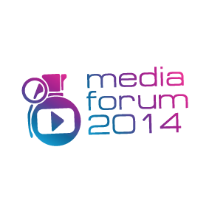
XV MediaForum in frame of 36th MIFF
“From Montage of Attractions to Neurocinema”
23-27 of June 2014
Venues: the Manege, ZIL House of Culture, Museum of Moscow

Organizers: Media Fest, MediaArtLab Centre for art and culture
Co-organizer:
Museum exhibition Complex Manege
Partners: Moscow Museum, Triumph Gallery, International Centre for Dance and Performance TsEKh, Theatre «Balet Moskva»/ Ballet Moscow
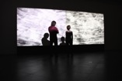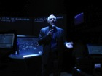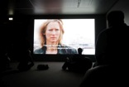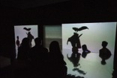

Current Media Forum is held at the Moscow International Film Festival for the 15th time. Such an age suggests not summing up but planning for the future.
The Medua Forum emerged as a footnote to the big text of the festival – a note about experimental cinema. Video art in its opposition to television was looking for a friendly support from the side of festival cinema. But the footnotes have been growing bigger, commentaries have turned into a separate text, and three years ago the XIII Media Forum took a step «Towards the Tactile Cinema» at the same time moving out of a cinema auditorium into an exhibition space. In particular, these were galleries' spaces and Moscow Museum of Modern Art, Cultural Foundation Ekaterina, and Garage Museum of Contemporary Art.
More than that, it has become more evident that the movement of cinema and contemporary art towards each other is not a marginal path but one of the well established roads that were used by film directors Sergey Eisenstein and Dziga Vertov, and artists Marcel Duchamp, Hans Richter, Mikhail Matiushin and Kazimir Malevich. The MIFF Media Forum has become one of the first festival projects (along with parallel programs of the festivals in Berlin and Venice) devoted to a systematic research of this crossroad. By the way, in 2014 this mission is carried out not only during the festival: along the whole year the MediaArtLab and Museum and Exhibition Association Manege hold an educational program “Projections of Avant-garde”.
Thanks to the Media Forum the MIFF public had an opportunity to watch daring experiments in the field of interactive cinema, sound performance and video art. The Media Forum venues presented works of such well-known artists and filmmakers as Eija-Liisa Ahtila, Peter Greenaway, Isaac Julien, Zbigniew Rybczynski, Eve Sussman, Fiona Tan, Harun Farocki, Omer Fast, Yang Fudong, Gary Hill, Jesper Just…
In 2014 the Media Forum continues to explore new territories. This year’s topics touch upon experiments at the junction of visual art, multimedia theatre and enactive cinema.
A new term of enactive cinema has entered academic discourse in 2008. Since then it gained many fans, as well as some skeptics. The fans, who develop scientific research on brain reactions towards visual images and events in the movie, share breathtaking prospects of, for example, collective screenings of personal dreams within a friendly circle or on youtube. What helps to create a collective movie out of dreams is chairs with bio-sensors designed to provide a literal connection between the viewer and the projection. It is supposed to be modified in accordance with her/his emotional and psycho-physic state. In other words, unlike interactive cinema where a person chooses an episode change consciously, within enactive cinema the viewer modifies the movie without even noticing it. The skeptics are of course concerned about a viewer becoming a sort of guinea pig, and insist that one likes to re-watch good movies without sensors.
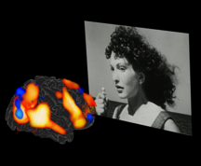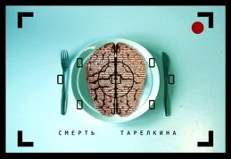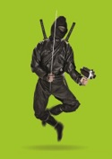

The main event of the Media Forum are a research conference From Montage of Attractions to Neurocinema (Central Exhibition Hall Manege), premiere of media performance The Death of Tarelkin created by the Open School Manege/MediaArtLab in collaboration with Centre for Dance and Performance TsEKh and Balet Moskva Theatre (House of Culture ZIL), exhibition “The Mist. The Stop” by Nikolay Onishchenko (with Triumph Gallery), interactive show Kino-harakiri by the Studio of Individual Directing.
Participants of the conference From Montage of Attractions to Neurocinema, including Alexander Deryabin, Nikolay Izvolov, Naum Kleiman, Kirill Razlogov, Pia Tikka (Finland), and Boris Yukhananov, will argue on prospects of theory and practice of neurocinema, on filmmaking as an art of manipulation with viewer's conscience, on hypnotism of the media and on artist’s eternal aspiration to enter the new spheres and to find new means of interaction with public.
For curator Alexandra Dementyeva, as well as for the artists of the MediaArtLab school, the new production of Sukhovo-Kobylin’s play Tarelkin’s Death is a dialogue with legendary production of 1922 by Vsevolod Meyerhold. Meyerhold interpreted the grotesque comedy as a modernist story – about a transformation of a person into a screw or a small wheel of red tape bureaucratic machine. Creators of today’s production, by transferring the action into today’s (or tomorrow’s) day, offer audience a chance to meet an updated modification of bureaucratic machine. Thanks to the newest technologies their authority over human being is invisible, ubiquitous and noctidial. A human being out of a screw or a wheel turns into a database, which can be copied, transferred, and used at one’s discretion. Kandid Tarelkin in the new production resurrects as a character resembling Edward Snowden.
Nikolay Onishchenko’s exhibition The Mist.The Stop will be shown in Manege, in mediatheque on the 2nd floor. Musician and artist, Onishchenko uses the minimum of means of expression in order to transform video images of empty urban playgrounds and underground parking lots into a metaphor of inner landscape, a sign of renouncement, of a stop. Three installations engage for direct transit: from the city to the territory of inner meditation.
The Kino-harakiri show created by students of the Studio of Individual Directing, is an attempt to turn the “death of the author” and of the cinema” narrative into a multimedia show. Kino-harakiri can be regarded as an answer to Peter Greenaway, provoked both by his Moscow project and by a concomitant educational program “Projections of avant-garde”.
Detailed information about the MIFF Media Forum at the website: http://mediaforum.mediaartlab.ru/
Press contacts:
Anna Buali +7 926 582 02 81
bualianna@gmail.com

